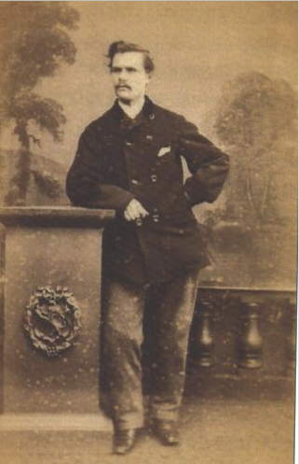
James Henderson BREMNER – 1865

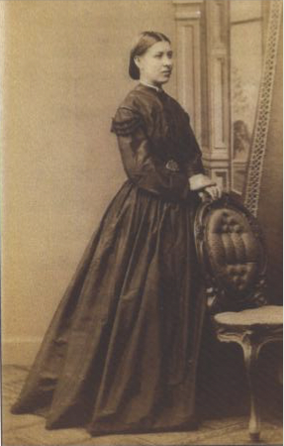
Jane WILLIAMSON 1867

